**Project Design Phase-II**

**Technology Stack (Architecture & Stack)**

|  |  |
| --- | --- |
| Date | 29 June 2025 |
| Team ID | LTVIP2025TMID35088 |
| Project Name | **Enhanced Wings: Marvels of Butterfly Species** |
| Maximum Marks | 4 Marks |

**Technical Architecture:**

The Deliverable shall include the architectural diagram as below and the information as per the table1 & table 2

**Reference:** [**https://liverfoundation.org/liver-diseases/complications-of-liver-disease/cirrhosis/**](https://liverfoundation.org/liver-diseases/complications-of-liver-disease/cirrhosis/)

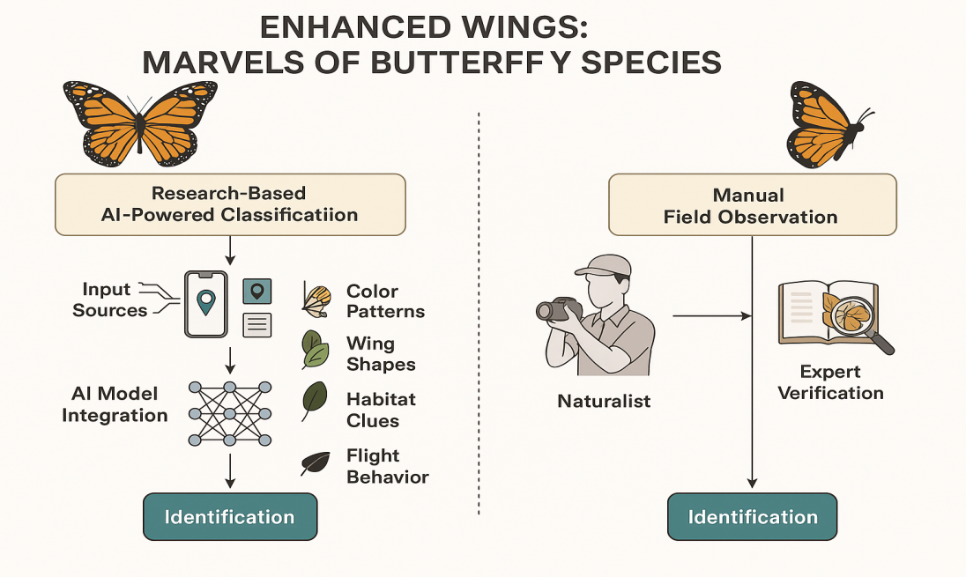

**Table-1 : Components & Technologies:**

|  |  |  |  |
| --- | --- | --- | --- |
| **S.No** | **Component** | **Description** | **Technology** |
|  | User Interface | Web and mobile app for uploading/viewing | HTML, CSS, JavaScript, Bootstrap (Web), Flutter (Mobile) |
|  | Application Logic-1 | User input, image upload, login | Python, Flask |
|  | Application Logic-2 | Butterfly species prediction (image) | Python, TensorFlow/Keras, OpenCV |
|  | Application Logic-3 | Manage species data and logs | SQLite / MongoDB |
|  | Database | Species info, image metadata | MongoDB |
|  | Cloud Database | Store butterfly images | Firebase / AWS DynamoDB |
|  | File Storage | Store butterfly images | Local Filesystem / Cloud (AWS S3) |
|  | External API-1 | Google login integration | Google OAuth API |
|  | External API-2 | (Optional: Biodiversity APIs) | GBIF, iNaturalist API |
|  | AI Model | Classify butterfly species via images | CNN model with TensorFlow/Keras |
|  | Infrastructure (Server / Cloud) | Runs locally or via cloud server | Flask server / Heroku / AWS EC2 |

**Table-2: Application Characteristics:**

|  |  |  |  |
| --- | --- | --- | --- |
| **S.No** | **Characteristics** | **Description** | **Technology** |
|  | Open-Source Frameworks | For AI and backend | Flask, TensorFlow, Keras, OpenCV |
|  | Security Implementations | Secure login, data access | OAuth 2.0, SHA-256 |
|  | Scalable Architecture | Modular for future feature addition | 3-Tier: (UI → Logic → DB/API) |
|  | Availability | Hosted locally or on cloud for global access | Cloud Hosting (optional) |
|  | Performance | Optimizedimage classification + fast UI | CNN Inference, Image Preprocessing |

**References**

<https://www.gbif.org/>

<https://www.inaturalist.org/>

<https://butterflyidentification.org/>

<https://en.wikipedia.org/wiki/Butterfly>